"Price-Promo-Margin Analytics: A Food Delivery Case Study

Project Matrix :

A Revenue Growth Management (RGM) Case Study | Akshay P Surve

- Tools & Technology Stack :
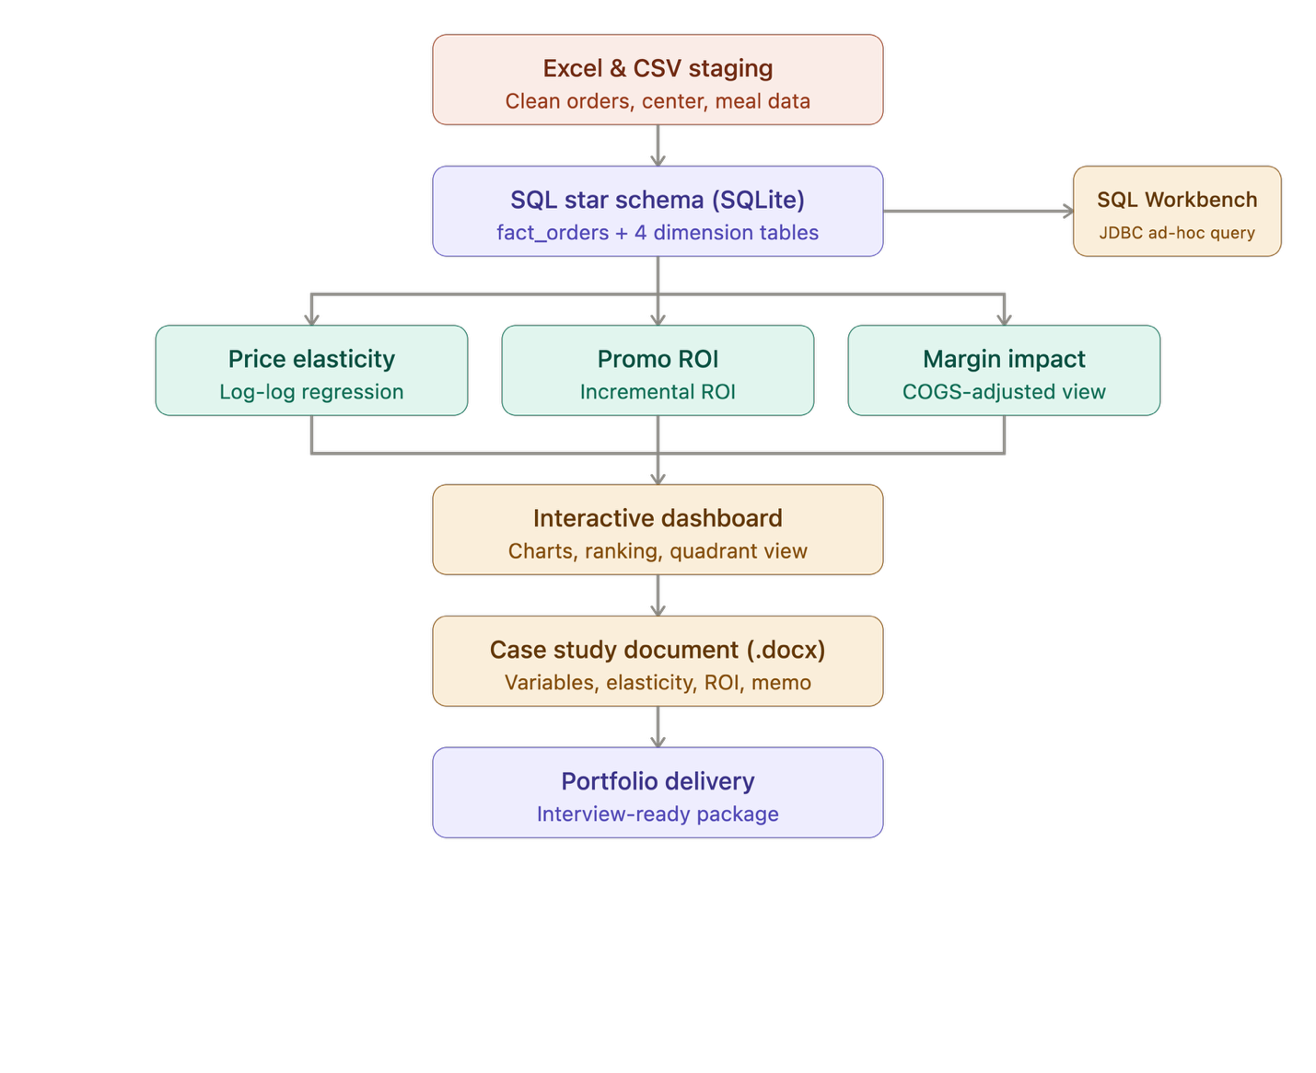

A.Layer | B. Tool / Technology | C. Purpose
1.Data staging | Excel | Raw CSV cleaning and initial structuring
2.Data source | Kaggle — Food Demand Forecasting | Order, center, and meal transactional data
3. Data modeling | SQLite (star schema) | fact_orders + 4 dimension tables, indexed
4.SQL querying / DB client | SQL Workbench/J (JDBC) | Ad-hoc querying against the star schema
5.Data pipeline / cleaning | Python — pandas | ETL, feature engineering (promo_flag, discount_depth, revenue)
6.Statistical modeling | Python — statsmodels (OLS) | Log-log price elasticity regression, 51 meal-level models
7.Database connectivity | Python — sqlite3 | Schema build & query layer
8.Visualization / dashboard | React + Recharts | Interactive tabbed dashboard (elasticity, ROI, margin quadrant)
9.Inline data viz | Chart.js | Scatter/decision visualizations
10.Documentation | docx (Node.js library) | Automated Word case-study generation
11.Architecture concepts applied | Fivetran, Snowflake, Power BI/DAX | Referenced pipeline/BI patterns from enterprise RGM stacks
12. Packaging | Bash / zip | Reproducible project delivery

2. Full Metrics Matrix

Metric | Value
Order-week records analyzed | 456,548
Fulfilment centers | 77
Meals (SKUs) | 51
Time span | 145 weeks
Dimension tables | 4 (meal, center, week, COGS assumptions)
Elasticity
Meals with significant elasticity (p<0.05) | 51 / 51 (100%)
Model fit (R²) range | 0.35 – 0.65
Price-elastic meals ( | e
Price-inelastic meals (pricing headroom) | 6 / 51 (12%)
Most elastic category | Seafood (avg. elasticity ≈ -3.86)
Most inelastic category | Extras (avg. elasticity ≈ -0.35)

Price PROMO :
Promoted order-week records | 138,745
Total trade spend (discount value) | $3.99B (modeled)
Total incremental gross margin | $3.56B (modeled)
Blended promo ROI | 0.89x
Meals with ROI ≥ 1x | 19 / 51 (37%)
Best-performing category (ROI) | Other Snacks (1.40x)
Worst-performing category (ROI) | Extras (0.03x)
Margin Impact
Meals volume + margin accretive | 49 / 51 (96%)
Meals margin-destructive | 2 / 51 (4%)
COGS assumption range (category-level) | 22% – 45% of base price
Deliverables produced
SQLite star-schema database | 1 (rgm_analytics.db, ~40MB)
Python analysis scripts | 3 (schema build, elasticity, promo ROI/margin)
Interactive dashboard (React artifact) | 1
Word case study document | 5 pages
SQL Workbench connection kit | 1 (JDBC profile + guide)

Built an end-to-end Revenue Growth Management analytics pipeline on 456,548 food-delivery order records (77 centers, 51 SKUs, 145 weeks), replicating the pricing/trade-marketing workflow used at CPG and food-delivery companies.
- Designed a SQL star schema (SQLite) with fact + 4 dimension tables, connected via JDBC in SQL Workbench for ad-hoc querying
• Built 51 meal-level log-log price elasticity regressions in Python (statsmodels) — 100% statistically significant, identifying 6 SKUs with real pricing headroom
• Quantified promotional ROI across 138,745 promo order-weeks, finding a blended 0.89x return with category-level ROI ranging 0.03x–1.40x
• Modeled COGS assumptions to separate volume-accretive promotions from margin-destructive ones, flagging 2 of 51 SKUs for discontinuation
• Delivered an interactive React/Recharts dashboard and a formal case-study document translating analysis into a 3-point pricing and trade-spend recommendation
Tools: Python (pandas, statsmodels, sqlite3) · SQL (SQLite, SQL Workbench/J) · React/Recharts · Chart.js · Excel · Word (docx automation)

4. Skills Demonstrated (RGM Pillar Mapping)

RGM Pillar | Applied Via
Smart Pricing | Elasticity model → pricing headroom identification
Trade Investment Optimization | Promo ROI ranking → keep/cut/scale decisions
Pack-Price / Margin Architecture | COGS-joined quadrant analysis
Commercial Storytelling | Interactive dashboard + recommendation memo
Data Engineering | Star schema design, ETL, SQL client connectivity

